AssetAtlas
User Guide
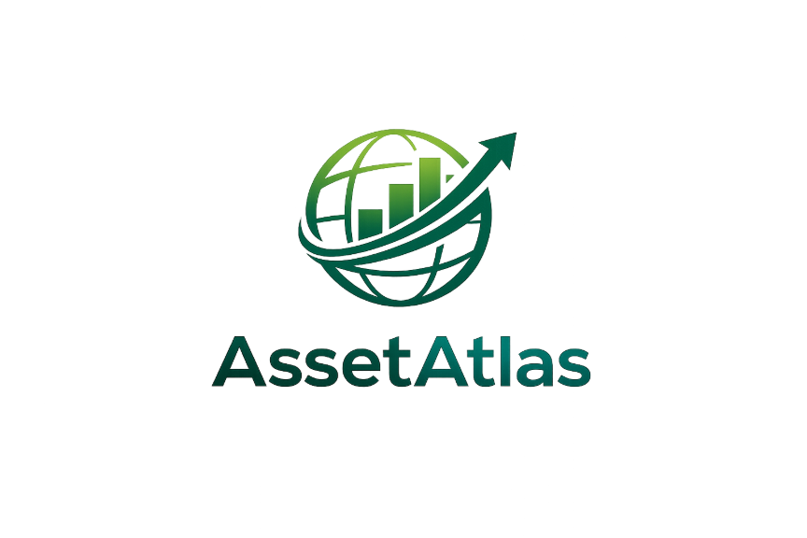

© 2026 AssetAtlas. All rights reserved.

Table of Contents

Introduction ........................................................................................ 3
Getting Started ................................................................................. 3
System Requirements ........................................................................ 3
Quick Start ........................................................................................ 3
Launching the Application ................................................................. 3
Navigating the App ............................................................................ 4
Registering an Account ..................................................................... 5
Logging In ......................................................................................... 6
Forgot Password ................................................................................ 6
Dashboard .............................................................................................. 7
Accounts ................................................................................................ 8
Viewing Accounts .............................................................................. 8
Adding an Account ........................................................................... 8
Deleting an Account .......................................................................... 9
Transactions ......................................................................................... 9
Viewing Transactions ........................................................................ 9
Adding a Transaction ...................................................................... 10
Deleting a Transaction ..................................................................... 10
Filtering Transactions ..................................................................... 11
Debts ................................................................................................... 11
Viewing Debts ................................................................................. 11
Making Payments ............................................................................ 12
Budgets ............................................................................................... 12
Viewing Budgets ............................................................................. 12
Creating a Budget ........................................................................... 13
Updating a Budget .......................................................................... 13
Deleting a Budget ........................................................................... 14
Transfers ............................................................................................. 14
Transferring Between Accounts ...................................................... 14
Making a Loan Payment ................................................................... 15
Profile & Settings ................................................................................ 15
Updating Personal Details ............................................................... 15
Changing Your Password ................................................................. 16
Language Settings ........................................................................... 17
Glossary .............................................................................................. 18

Introduction

Managing personal finances can be overwhelming without the right tools. AssetAtlas is a personal finance web application designed to give you a clear, real-time picture of your financial life — all in one place.
With AssetAtlas you can:
- Track checking, savings, and high-yield savings accounts
- Monitor debts including auto loans, mortgages, and credit cards
- Record and categorize daily transactions
- Set monthly spending budgets by category
- Transfer money between accounts and make loan payments
- View your financial overview at a glance on the Dashboard
AssetAtlas is built for everyday users who want to take control of their money without needing a background in finance. The interface is clean and straightforward — everything you need is one click away from the sidebar.

Getting Started

System Requirements
- A modern web browser (Chrome, Firefox, Edge, or Safari)
- Internet connection or local network access
- The application running locally or hosted on a server
Quick Start

- Open your web browser.
- Navigate to: https://capstone-frontend-j6bg.onrender.com
- You will see the AssetAtlas landing page.
- Click Get Started to register, or Login if you already have an account.

Launching the Application

The landing page will appear, welcoming you to AssetAtlas.
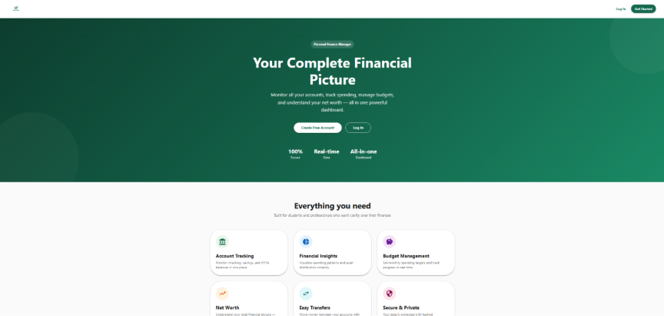
From here you can choose to register a new account or log in to an existing one.

Navigating the App

Once logged in, you will see a sidebar on the left side of the screen. This is the main navigation menu for AssetAtlas.
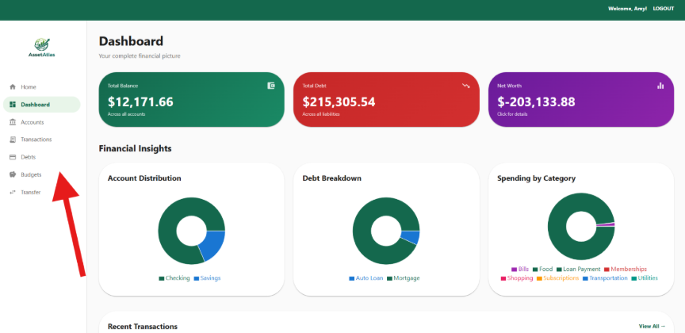
The full app layout showing the left sidebar with all navigation items: Dashboard, Accounts, Transactions, Debts, Budgets, Transfer, and Profile
The sidebar contains the following sections:
Dashboard A summary of your overall financial health.
Accounts View and manage your checking, savings, and HYSA accounts.
Transactions View, add, and delete individual transactions.
Debts Track loans, mortgages, auto loans, and credit cards.
Budgets Set and monitor monthly spending limits by category.
Transfer Move money between accounts or make a loan payment.

Registering an Account

To create a new AssetAtlas account:
- From the landing page, click Get Started.
- Enter your First Name and Last Name.
- Enter a valid Email Address.
- Create a Password. Your password must be at least 8 characters and contain at least one number and one special character (e.g., Password123!).
- Select a Security Question from the dropdown.
- Enter your Security Answer.
- Click Register.
- 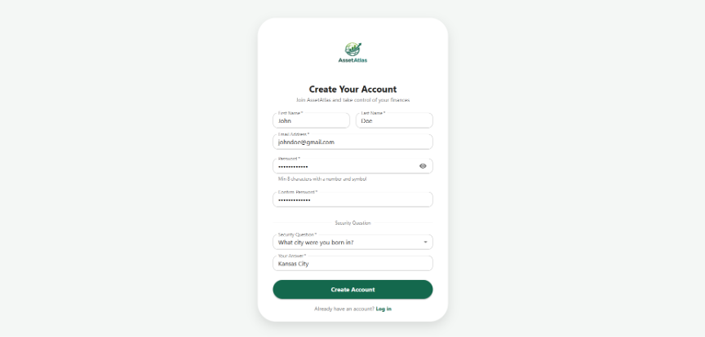
The registration form with all fields filled in and the Register button visible at the bottom
Once registered, you will be redirected to the login page.

Logging In

To log in to AssetAtlas:
- From the landing page, click Login.
- Enter your Email Address.
- Enter your Password.
- Click Login.
- 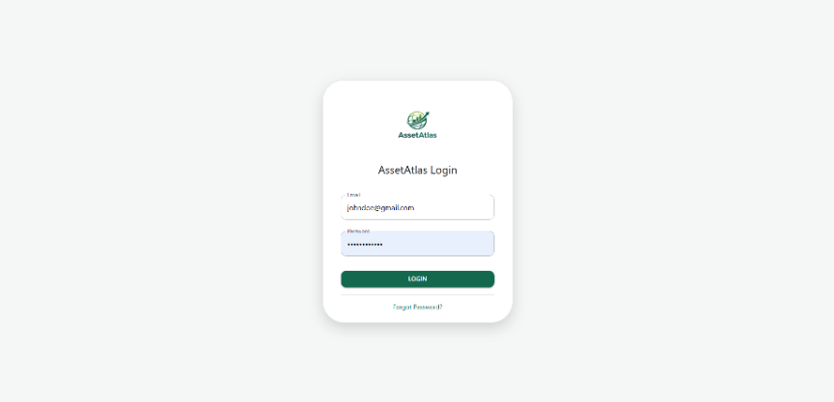
The login page showing the email and password fields and the Login button
After a successful login, you will be taken directly to the Dashboard.

Forgot Password

If you have forgotten your password:
- On the login page, click Forgot Password.
- Enter the Email Address associated with your account.
- Click Submit. Your security question will appear.
- Enter the answer to your security question.
- Enter your New Password.
- Confirm your new password.
- Click Reset Password.
- 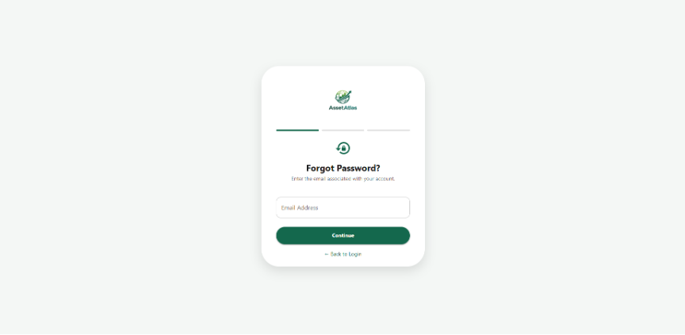
The forgot password page showing the security question displayed and the new password fields below it
You will be redirected to the login page once your password has been reset successfully.

Dashboard

The Dashboard gives you an at-a-glance overview of your finances. To access the Dashboard, click Dashboard in the sidebar.
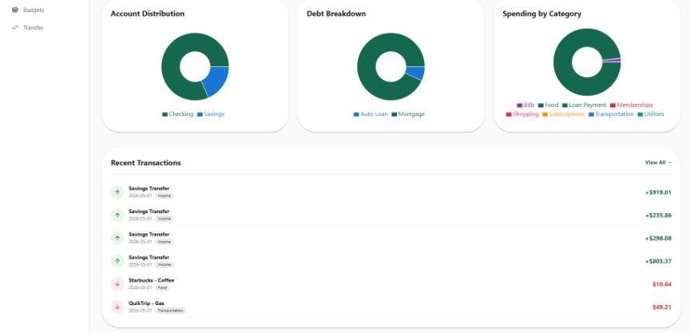
The full Dashboard page showing account balance summary cards, recent transactions, and spending overview
The Dashboard displays:
- Total Balance — the combined balance across all your asset accounts
- Total Debt — the combined outstanding balance across all debt accounts
- Recent Transactions — your most recent activity
- Spending Summary — a breakdown of spending by category for the current month

Accounts

Viewing Accounts
To view your accounts, click Accounts in the sidebar. Your checking, savings, and high-yield savings accounts will be listed, each showing the account name, type, current balance, and interest rate (APY).
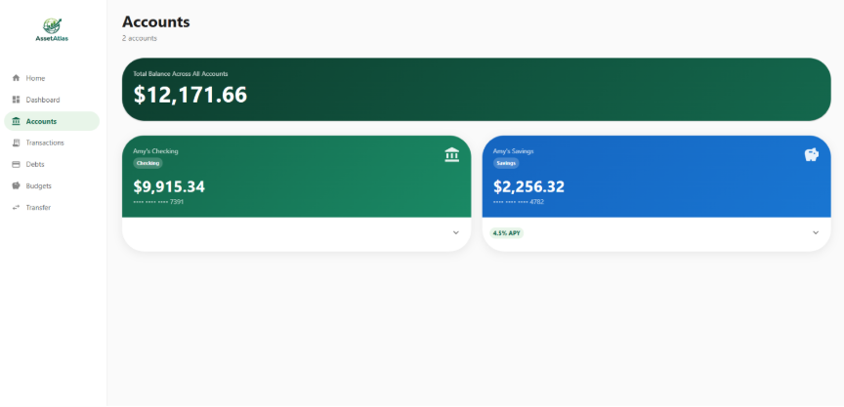
The Accounts page showing a list of accounts with their balances and account types displayed as cards or rows
Adding an Account
To add a new account:
- On the Accounts page, click Add Account.
- Enter the Account Name (e.g., My Checking).
- Select the Account Type from the dropdown (Checking, Savings, or HYSA).
- Enter the Starting Balance.
- Enter the APY (interest rate), if applicable.
- Click Save.
- 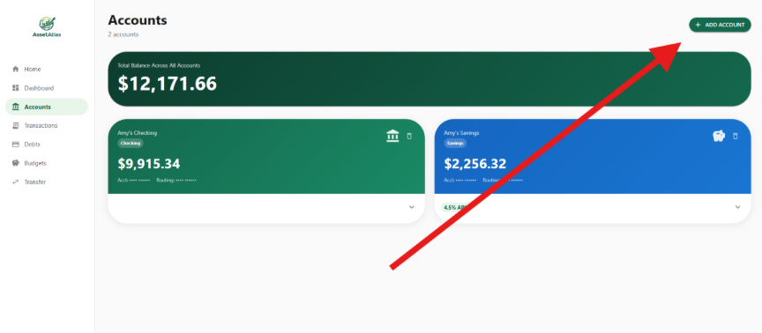
The Add Account form or modal showing all input fields and the Save button
Deleting an Account
To delete an account:
- On the Accounts page, find the account you wish to remove.
- Click the Delete button (trash icon) next to that account.
- Confirm the deletion when prompted.
Note: Deleting an account will also remove all transactions associated with it. This action cannot be undone.

Transactions

Viewing Transactions
To view your transactions, click Transactions in the sidebar. All transactions across your accounts will be listed, showing the date, description, category, and amount.
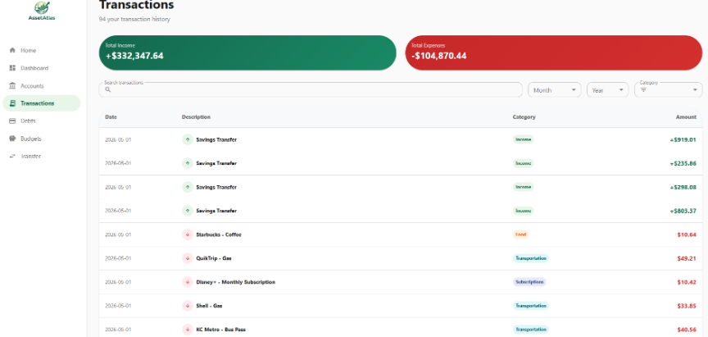
The Transactions page showing a list of transactions with columns for date, description, category, and amount
Adding a Transaction
To add a new transaction:
- On the Transactions page, click Add Transaction.
- Select the Account the transaction belongs to.
- Enter the Amount. Use a negative number for expenses (e.g., -45.00) and a positive number for income (e.g., 2500.00).
- Select a Category (e.g., Food, Bills, Income).
- Enter a Description (optional).
- Click Save.
- 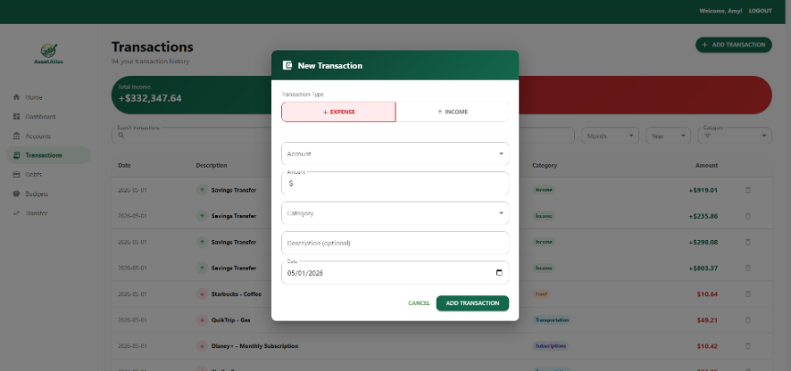
The Add Transaction form or modal showing the account dropdown, amount field, category selector, and description field
Deleting a Transaction
To delete a transaction:
- On the Transactions page, find the transaction you wish to remove.
- Click the Delete button (trash icon) next to that transaction.
- Confirm the deletion when prompted.
Filtering Transactions
To filter transactions by month or category:
- On the Transactions page, locate the filter controls at the top.
- Select a Month and Year to view transactions for that period.
- Optionally select a Category to narrow results further.
- The list will update automatically.
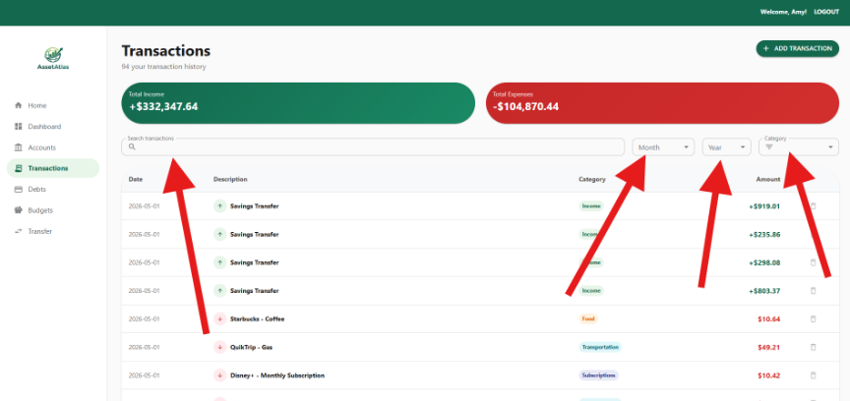The Transactions page with the filter dropdowns open, showing month, year, and category filter options

Debts

Viewing Debts
To view your debts, click Debts in the sidebar. All debt accounts (auto loans, mortgages, personal loans, and credit cards) will be listed, showing the balance owed, APR, monthly payment, and payments remaining.
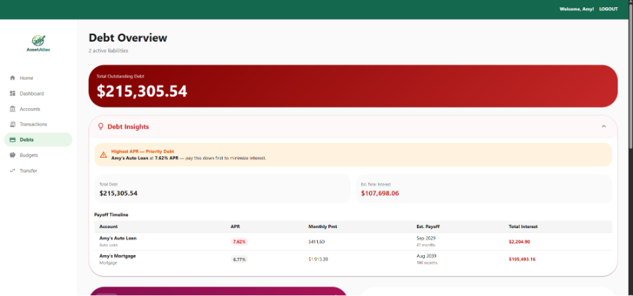
The Debts page showing debt cards with balance, APR, monthly payment, and a Paid This Month indicator
Making Payments
To Make a payment to a desired debt account:
- On the Debts page, find the debt you wish to make a payment towards.
- Click the “Pay Now” button next to that debt.
- The Debt balance will automatically be updated

Budgets

Viewing Budgets
To view your budgets, click Budgets in the sidebar. Your budgets for the current month will be displayed, showing each category, the amount budgeted, and how much has been spent so far.
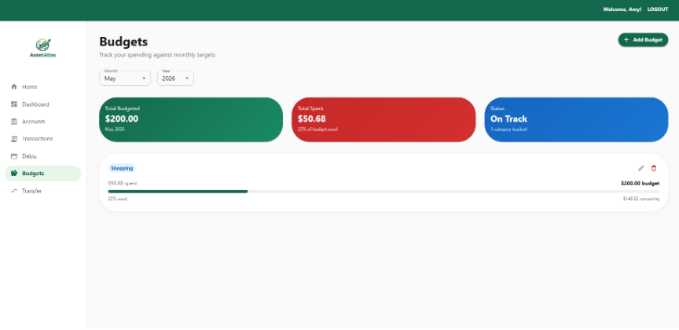

The Budgets page showing budget cards or progress bars for each category with the budgeted amount vs amount spent
Creating a Budget
To create a new budget:
- On the Budgets page, click Add Budget.
- Select a Category (e.g., Food, Bills, Shopping).
- Enter the Budget Amount for the month.
- Click add budget .
- 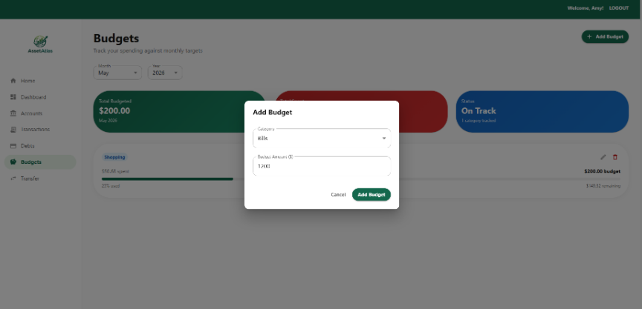
The Add Budget form or modal showing the category dropdown, amount field, and month/year selectors
Updating a Budget
To change your budget amount for a category:
- On the Budgets page, find the budget you want to change.
- Click the Edit button (pencil icon).
- Enter the new Budget Amount.
- Click Save.
Deleting a Budget
To delete a budget:
- On the Budgets page, find the budget you want to remove.
- Click the Delete button (trash icon).
- Confirm the deletion when prompted.

Transfers

Transferring Between Accounts
To move money from one account to another:
- Click Transfer in the sidebar.
- Select the From Account (the account money is leaving).
- Select the To Account (the account money is going into).
- Enter the Amount to transfer.
- Enter an optional Memo to describe the transfer.
- Click Transfer.
- 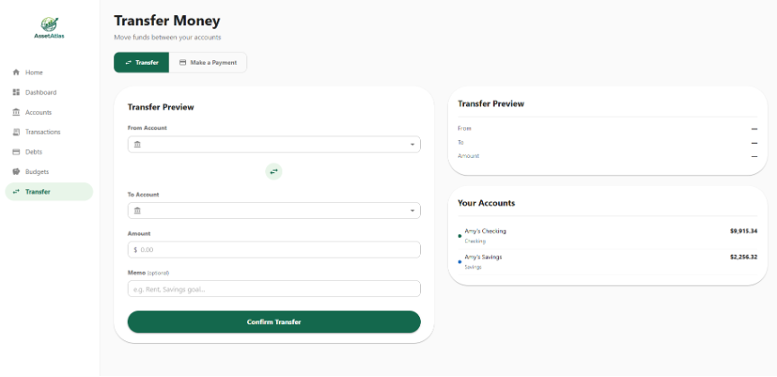
The Transfer page showing the From Account and To Account dropdowns, amount field, memo field, and Transfer button
Both accounts will update immediately to reflect the new balances.
Making a Loan Payment
Making a loan payment works the same way as a transfer, but the destination is a debt account.
- Click Transfer in the sidebar.
- Set the From Account to your checking or savings account.
- Set the To Account to your loan or debt account.
- Enter the Payment Amount.
- Click Transfer.
The payment will be recorded as a Loan Payment transaction and your debt balance will be reduced accordingly.
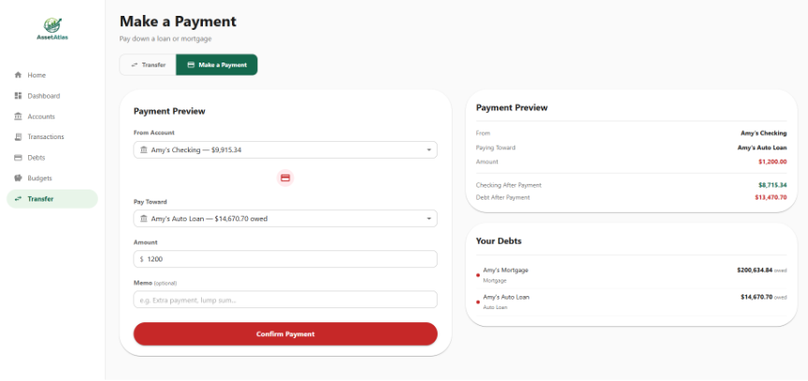The Transfer page with a checking account selected as the source and a mortgage or auto loan selected as the destination

Profile & Settings

Updating Personal Details
To update your name or email address:
- Click your name in the top right corner of the top nav bar.
- Click Personal Details.
- Update your First Name, Last Name, or Email.
- Click Save Changes.
- 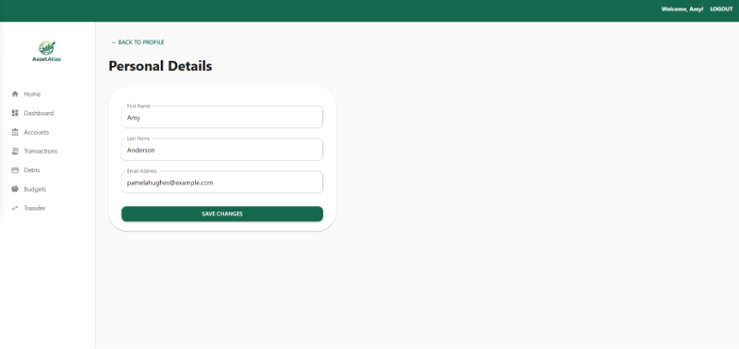
The Personal Details page showing the editable first name, last name, and email fields with a Save Changes button
Changing Your Password
To change your password:
- Click your name in the top right corner of the top nav bar.
- Click Login Preferences.
- Enter your Current Password.
- Enter your New Password.
- Confirm the new password.
- Click Save.
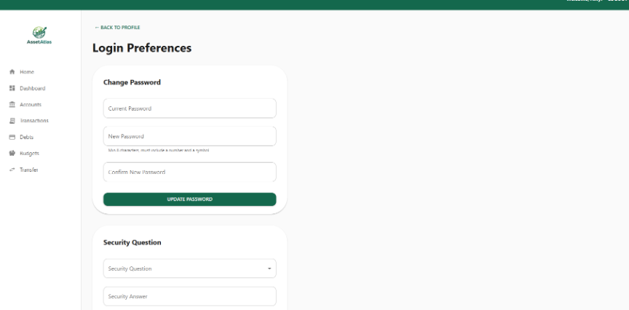
Note: Passwords must be at least 8 characters and contain at least one number and one special character.
The Login Preferences page showing the current password, new password, and confirm password fields
Language Settings
AssetAtlas supports multiple display languages. To change the display language:
- Click your name in the top right corner of the top nav bar.
- Click Language Settings.
- Select your preferred language from the list.
- Click Save.
- 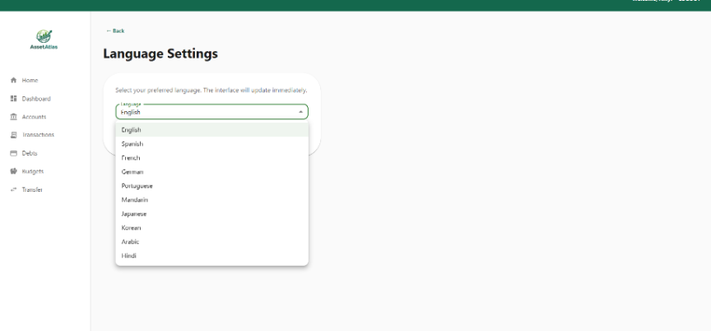
The Language Settings page showing a list of available languages with the currently selected one highlighted

Glossary

APR (Annual Percentage Rate)
The yearly interest rate charged on a debt account such as a loan or credit card.
APY (Annual Percentage Yield)
The yearly interest rate earned on a savings or HYSA account.
Budget
A monthly spending limit set for a specific category such as Food or Bills.
Category
A label applied to a transaction to group spending (e.g., Food, Shopping, Income, Utilities).
Dashboard
The home screen of AssetAtlas, showing a summary of all accounts, balances, and recent activity.
Debt Account
An account that represents money owed, such as an auto loan, mortgage, personal loan, or credit card.
HYSA (High-Yield Savings Account)
A savings account that earns a higher interest rate than a standard savings account.
Lender
The financial institution that issued a loan (e.g., Chase, Wells Fargo).
Loan Payment
A transfer made from an asset account to a debt account to reduce the outstanding balance.
Transaction
A record of money moving in or out of an account. Positive amounts represent income or deposits. Negative amounts represent expenses or payments.
Transfer
The movement of funds from one account to another within AssetAtlas.

AssetAtlas User Guide — © 2026

